**Model Building**

**Logistic Regression:**

**Used parameters:**

**solver**: lbfgs, Algorithm to use in the optimization problem.

**class_weight**: balanced, mode uses the values of y to automatically adjust weights inversely proportional to class frequencies in the input data.

**penalty**: l2, used to specify the norm used in the penalization.

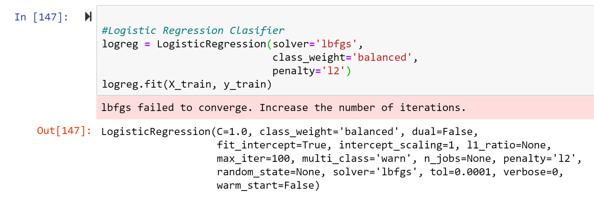

**Random Forest:**

**Important parameters:**

**solver**: lbfgs, Algorithm to use in the optimization problem.

**class_weight**: balanced, mode uses the values of y to automatically adjust weights inversely proportional to class frequencies in the input data.

**penalty**: l2, used to specify the norm used in the penalization.

